**LAB # 05**

**Task # 1: Using python implement Naïve Bayes with two different splitting ratios on Heart Attack Analysis & prediction dataset to predict the chances of heart failure in a person and performed the following steps:**

* **Data Pre-processing step**
* **Fitting Naive Bayes to the Training set**
* **Predicting the test result**
* **Test accuracy of the result(Creation of Confusion matrix)**
* **Visualizing the test set result.**

**Compare the accuracies**

**Solution:**

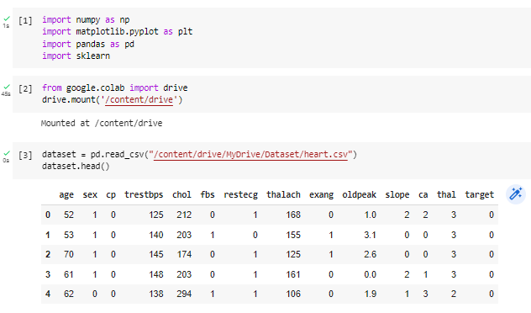

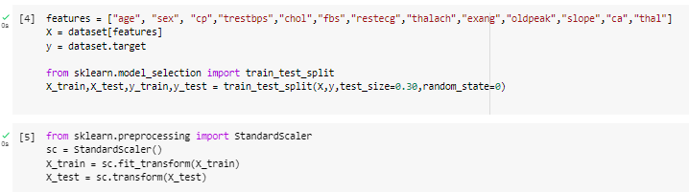

|  |  |
| --- | --- |
| **When test size is 30%** | **When test size is 40%** |
|  |  |

**CONFUSION MATRIX**

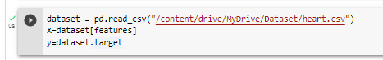

**Task # 2: Design a workflow with the help of Knime to predict whether a user buys a product by clicking the ad on the site based on their salary, age, and gender dataset provided in the lab (i.e. Social network ad dataset).**

**Solution:**

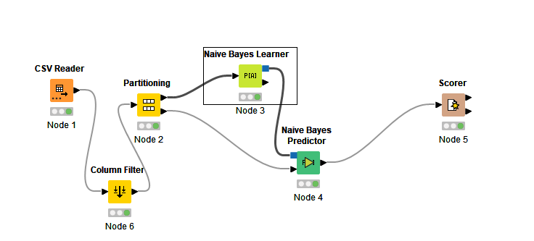

**Output:**

